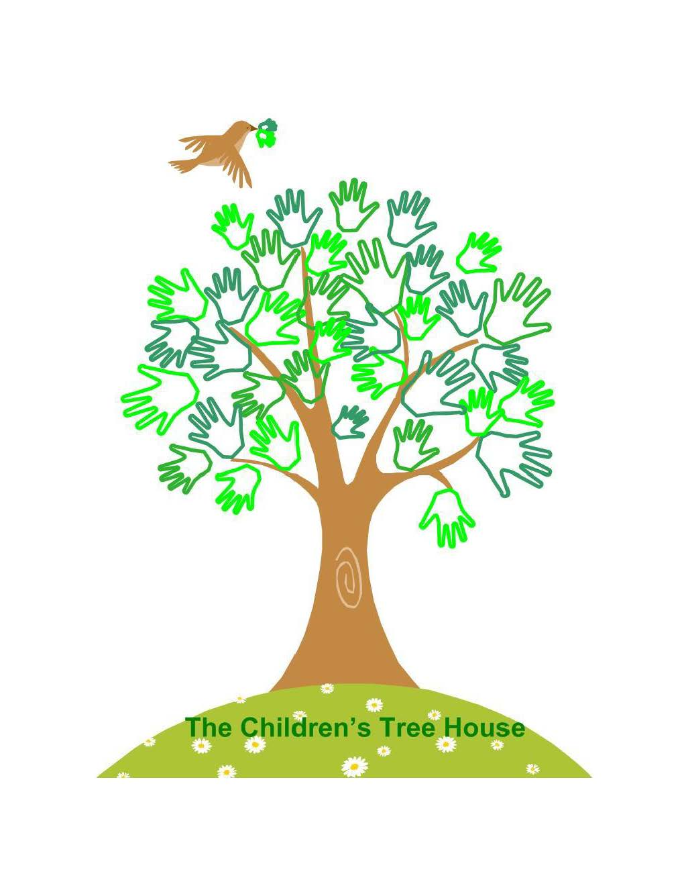
Children’s Tree House, Inc. Waiting list application
Child’s name:__________________________ Age: ________ D.O.B. ____/____/____

Desired date of Entrance: _____/_____/_____

Program: (Please Circle)
Infant Toddler Two’s Three’s Pre-K Summer Camp

Parent/Guardian Names: ___________________________________________________

Home Address: ___________________________________________________________
Street Address
__________________________________________________________
City State Zip
Home Phone: ___________________ Work/Cell Phone: ____________________

Email Address:_______________________________________________
How did you hear about CTH (Children’s Tree House, Inc): _______________________
I understand that……
- A non-refundable registration fee of $50.00 per child is required to be recorded and placed on the waiting list.
- Placing your child on the waiting list does not guarantee my child’s enrollment.
- The waiting list is reviewed on a first come first serve basis.
- If a space becomes available close to the time of the desired enrollment, You will be notified by email, and you have 48 hours to respond. If you fail to respond by email, your name will be moved to the bottom of the list.
- If you are called about an available space, you can verbally decline the available space and your name will remain in the waiting list. You can pass two (2) times before your name is removed from the list
- If you are called about an available space, and you accept that space you must pay a non-refundable acceptance deposit of two weeks tuition, with-in 3 days. Once my child starts this deposit will be applied to the last two weeks of care.
Signed: ______________________________________ Date: _____/_____/_____

Office use only: Date: _____/_____/_____ Amount: _______ Cash/Check #:________
Contacts:
Date: __________ Notes:__________________________________________________
Date: __________ Notes:__________________________________________________
Date: __________ Notes:__________________________________________________

